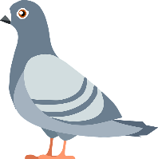
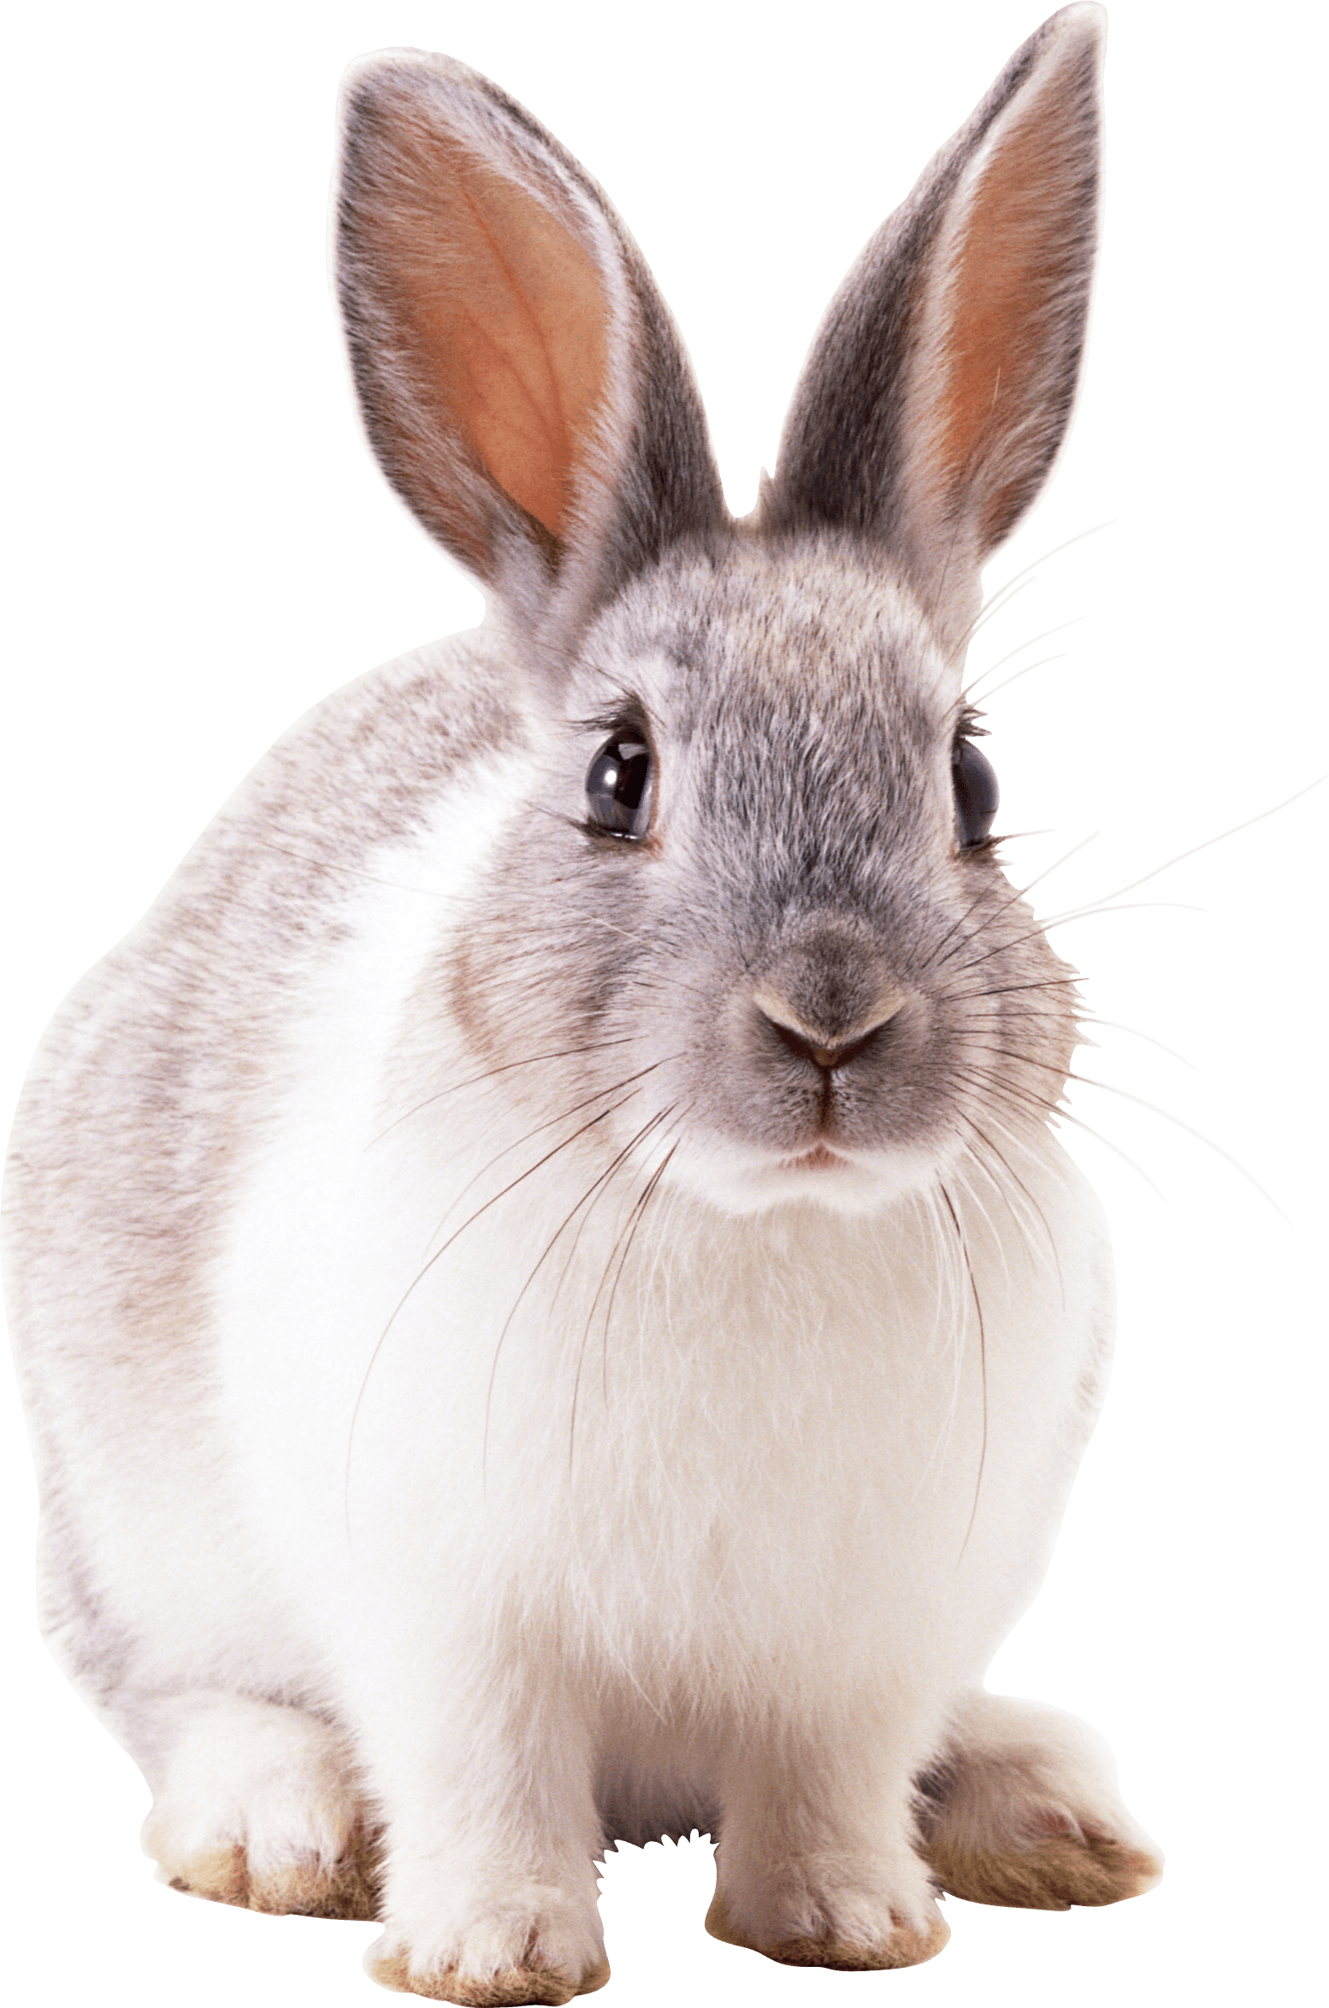
Dayton Fancy Feather Club Spring Swap
This Photo by Unknown Author is licensed under CC BY-NC
This Photo by Unknown Author is licensed under CC BY-NC
**Buy*Sell*Trade**
$15.00 Vendor Fee

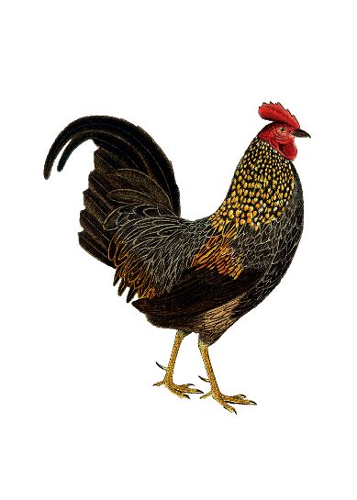
April 14, 2024
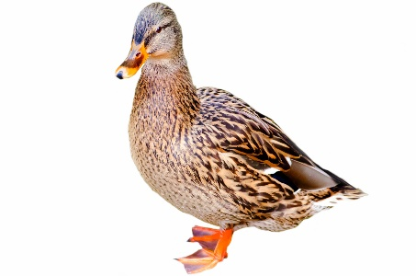
Darke County Fairgrounds
Greenville, Ohio

6:00 AM – 12:00 PM

Chickens, Ducks, Geese, Peafowl, Turkeys, Pigeons, Rabbits, Plants,
Cages, & Equipment

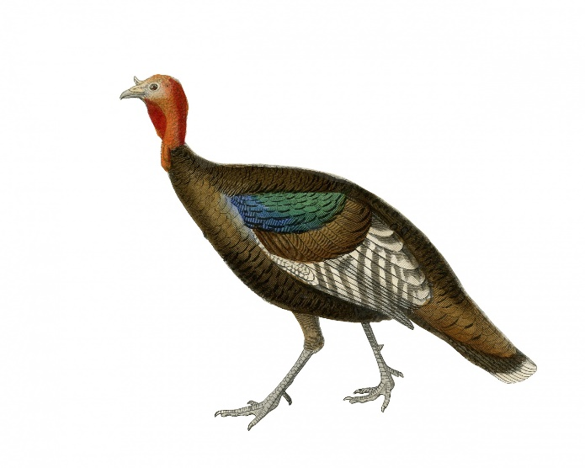
Learn More:
Call: (937) 681-6002
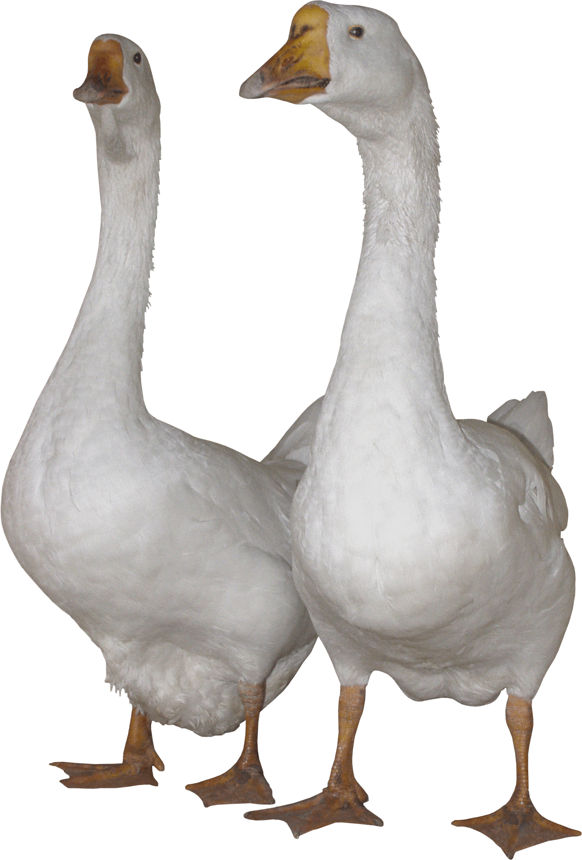
Email: daytonfancyfeatherclub@gmail.com
This Photo by Unknown Author is licensed under CC BY-NC
Website: www.daytonfancyfeatherclub.com

Breakfast/Lunch Stand on Site

Rain or Shine
Photos: Microsoft Office 2021, Creative Commons

